Documentation for Scale DataBase Loader and CDU File Generator

1. Scale Database Loader

Go to production machine 434888340;

Go to folder S:\IT\Production\Scripts\python\ScaleDataLoader\bin;

Double Click ScaleDataLoader.xlsm;

The YELLOW area is user’s input:
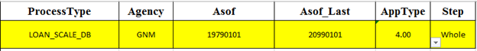
Here the user can select:
(1) ProcessType (dropdown): Loan Level / Pool Level
(2) Agency (dropdown): FHL / FNM / GNM
(3) Asof (user): The start date of the data, format: yyyymmdd
(4) Asof_Last (user): The end date of the data, format: yyyymmdd
(5) AppType (dropdown): The Database Version user wants to load data in, 4.00 / 9.99
(6) Step (dropdown): Which part of the data user wants to load in, Whole / step 1 / step 2 / step 3 / step 4 / step 5 / step 6 / step 7
The user can check the content of each step at the GREEN area:
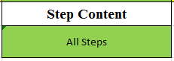
If there is no content it will show “ERROR!!” (for example, there is no step 7 for GNM loans)
The user can also see which python file it will call at the GREEN area:
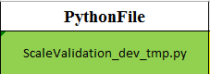

Check if the Batch file content is correct at ORANGE area:
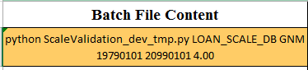

Click Button “Load Data” to load data into scale database automatically;

Check Job Status at scale.jobstatus table

Timetable:

 | FHL | FNM | GNM
Whole History
One Month

2. CDU File Generator (in Excel)

Go to production machine 434888340;

Go to folder S:\IT\Dev\Scripts\python\CDULoader\python;

Double Click CDUGenerator.xlsm;

The YELLOW area is user’s input:
Here the user can select:
(1) ProcessType (currently only ‘extractBondIndicatives’): what type of cdu file to produce
(2) Asof (user): select the month to generate cdu files for, format: yyyymmdd
(3) Rootpath (user): select the folder to put cdu files,
## S:/IT/Dev/Scale/Instrument/Repline_chentest ##
(4) Agency (dropdown): FHL / FNM / GNM
(5) DataLevel (dropdown): LL / PL
(6) AppType (dropdown): The Database Version user wants to generate cdu files from, 4.00 / 9.99
The user can also see which python file it will call at the GREEN area:

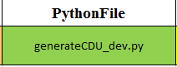
Check if the Batch file content is correct at ORANGE area:
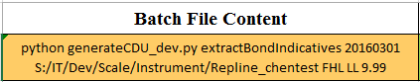
Click Button “Load Data” to load data into scale database automatically, the output files will be saved in rootpath

3. CDU File Generator (in cmd)

Go to remote desktop connection 172.16.74.135;

Open cmd, type ‘cd S:/IT/Dev/Scripts/python/CDULoader/python’;

Type in argument:
‘python -u generateCDU_dev.py extractBondIndicatives 20180301 C:/temp/CDUFiles FHL LL 9.99’

argv[1]: processtype, extractBondIndicatives
argv[2]: asof, format: yyyymmdd
argv[3]: rootpath, C:/temp/CDUFiles
argv[4]: agency, FHL / FNM / GNM
argv[5]: datalevel, LL / PL
argv[6]: apptype, 4.00 / 9.99

Run the process to generate cdu files in rootpath folder;

Zip cdu files in rootpath folder, copy zipped document to:
## S:/IT/Dev/Scale/Instrument/Repline_chentest ##

Unzipped cdu files at local machine

